The State of Health Workforce
In the WHO African Region

2nd Edition

2024

Table of Contents
List of Tables iv
List of Figures v
Foreword vi
Acknowledgements vii
Abbreviations viii
Executive summary ix
1. Background 1
1.1 Introduction 1
1.2 Scope of the report 1
1.3 Policy and statutory framework 1
1.4 State of health systems and service provision in the African Region 1
1.5 Overview of the health workforce in the African Region 2
1.6 Health workforce issues and challenges in the African Region 2
1.7 Health workforce post COVID-19 pandemic 2
1.8 Health workforce resilience to disasters and pandemics 2
2. Methodology 3
2.1 Data collection 3
2.2 Analysis approach 3
2.3 Limitations 3
3. Regional health workforce profile 4
3.1 Trends in the stock and density of health workers in the region 4
3.2 Trends in the stock and density of health workers within the economic blocks 5
3.3 Trends in the stock and density of health workers with countries income levels 6
4. Health Education, Training and Accreditation 8
4.1 Health training institutions 8
4.2. Accreditation of health training institutions 8
5. Health workforce labour flows 8
6. Health workforce (un)employment rates 8
7. Supply, demand and the need for health care workers 9
8. Health workforce budget and spending 10
9. Governance and management of health workforce 11
10. Status of health workforce through the lenses of performance indicators 12
11. Synthesis of health workforce trends and their impacts 13
12. Conclusions 14
13. Recommendations 15
References 16
Appendices 17

List of Tables

List of Figures

Figure 1: The trend of doctors, nurses and midwives per 10,000 in the WHO AFRO region 4
Figure 2: Compound annual growth of Health Workforce between 2005 and 2021 in the WHO AFRO region 4
Figure 3: The trends of doctors, nurses and midwives density per 10,000 population between 2005 and 2021 with the trading blocks 5
Figure 4: Compound annual growth of Health Workforce between 2005 and 2021 in the WHO AFRO region with the trading blocks 6
Figure 5: Densities of doctors, nurses and midwifes per 10,000 population with income groups 6
Figure 6: Compound annual growth of Health Workforce between 2005 and 2021 in the WHO AFRO region with income levels 6

Foreword

Acknowledgements

Abbreviations

Executive summary

- Background

  - Introduction

Build from the first edition and highlight the new developments since the edition release

  - Scope of the report

This report is a triangulation and analysis of all available data and evidence from NHWA, HLMA reports and published literature on the health workforce in order to establish:
  - A 10-year trends in the stock and density of health workers in the Region and per country disaggregate by country types: HIC, LMIC, East, Southern Africa, West Africa and Central Africa; WHO SSL 2023; by cadres
  - The status of training and Education capacities in the Region
  - The Labour flows (inflows and out-flows) including migration
  - Health workforce (un)employment
  - The projected supply, demand and need for health workers
  - The health workforce budgeting and spending
  - State of health workforce governance and stewardship/leadership
  - The reasons for the observed trends and the impact of HWF on health and socio-economic indicators.
  - Status of key performance indicators compared to targets/thresholds
  - Recommendations for the next of half of the SDG era, 2025 – 2030.

  - Policy and statutory framework

Build from the first edition and highlight the new developments since the edition release
Besides the policies add the relevant laws that have moderated the health workforce practice in the member states (cite a few)

  - State of health systems and service provision in the African Region

Build from the first edition and highlight the new developments since the edition release

  - Overview of the health workforce in the African Region

Build from the first edition and highlight the new developments since the edition release

  - Health workforce issues and challenges in the African Region

Build from the first edition and highlight the new developments since the edition release

  - Health workforce post COVID-19 pandemic

Indicated how the health workforce have bounced back after the pandemic

  - Health workforce resilience to disasters and pandemics

Highlight the current resilience to shocks emanating from disasters and pandemics. This is majorly from literature. It will be from the lessons learnt.

- Methodology

2.1 Data collection

Highlight the various data elements, their source and scope

2.2 Analysis approach

For each of the activities, the analysis approach to be indicated against each:

  - A 10-year trends in the stock and density of health workers in the Region and per country disaggregate by country types: HIC, LMIC, East, Southern Africa, West Africa and Central Africa; WHO SSL 2023; by cadres
  - The status of training and Education capacities in the Region
  - The Labour flows (inflows and out-flows) including migration
  - Health workforce (un)employment
  - The projected supply, demand and need for health workers
  - The health workforce budgeting and spending
  - State of health workforce governance and stewardship/leadership
  - The reasons for the observed trends and the impact of HWF on health and socio-economic indicators.
  - Status of key performance indicators compared to targets/thresholds
  - Recommendations for the next of half of the SDG era, 2025 – 2030.

2.3 Limitations

XXXXXXXXX

- Regional health workforce profile

To add current segregation by cadre, age group and gender

3.1 Trends in the stock and density of health workers in the region

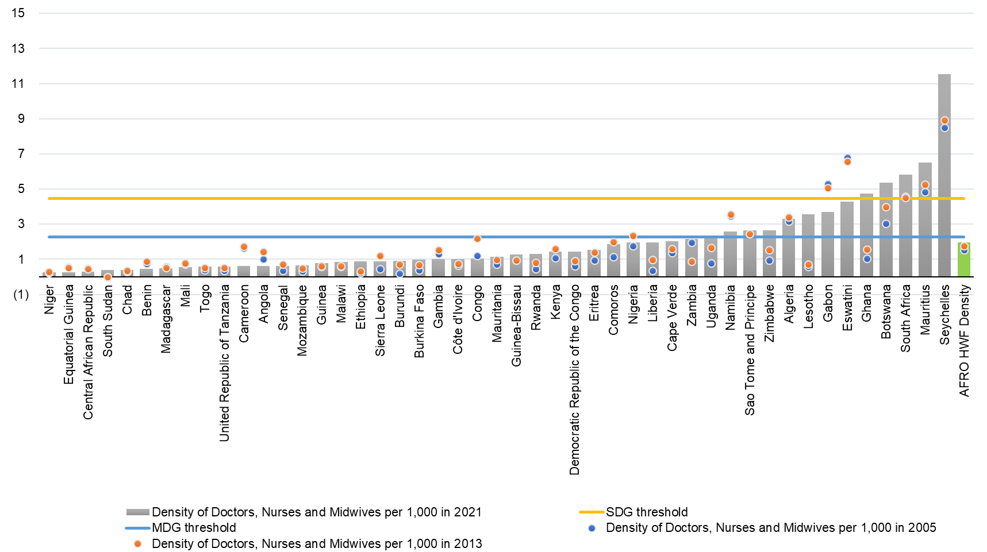

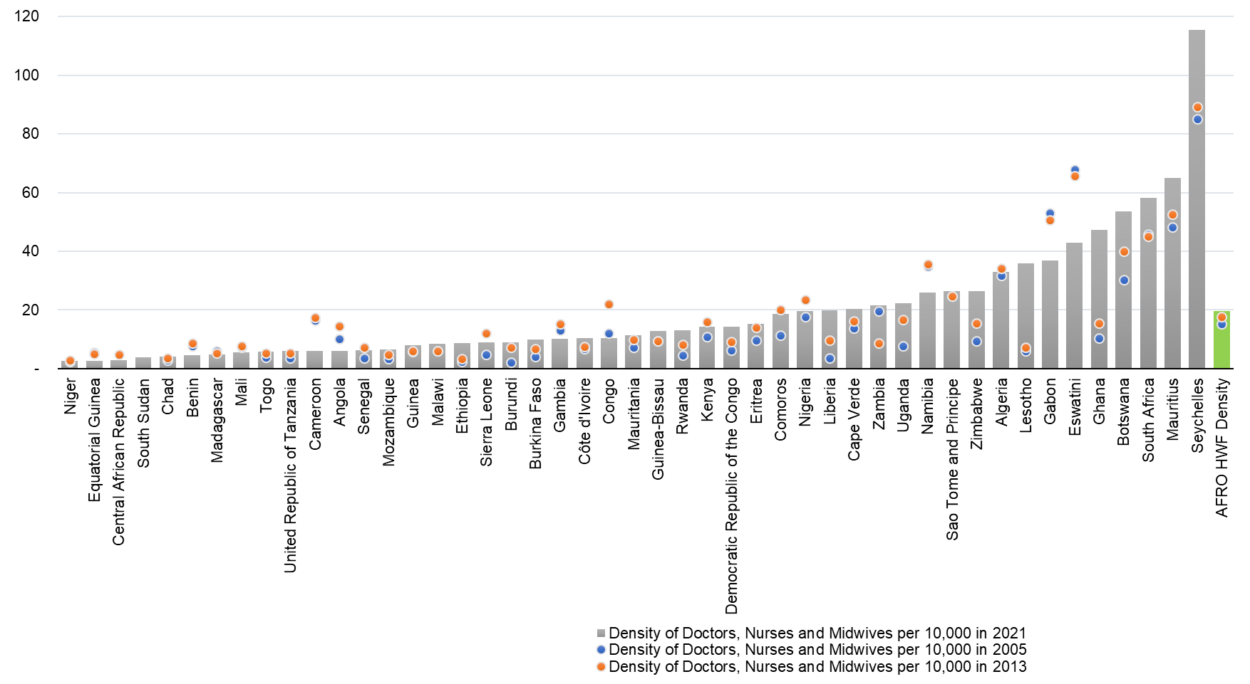
Figure 1: The trend of doctors, nurses and midwives per 10,000 in the WHO AFRO region

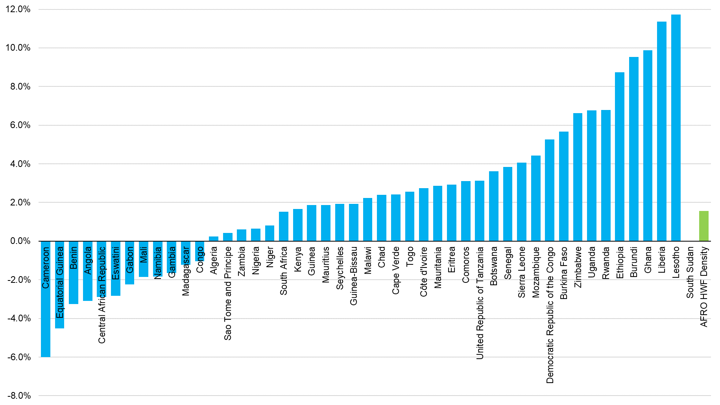
Figure 2: Compound annual growth of Health Workforce between 2005 and 2021 in the WHO AFRO region

3.2 Trends in the stock and density of health workers within the economic blocks

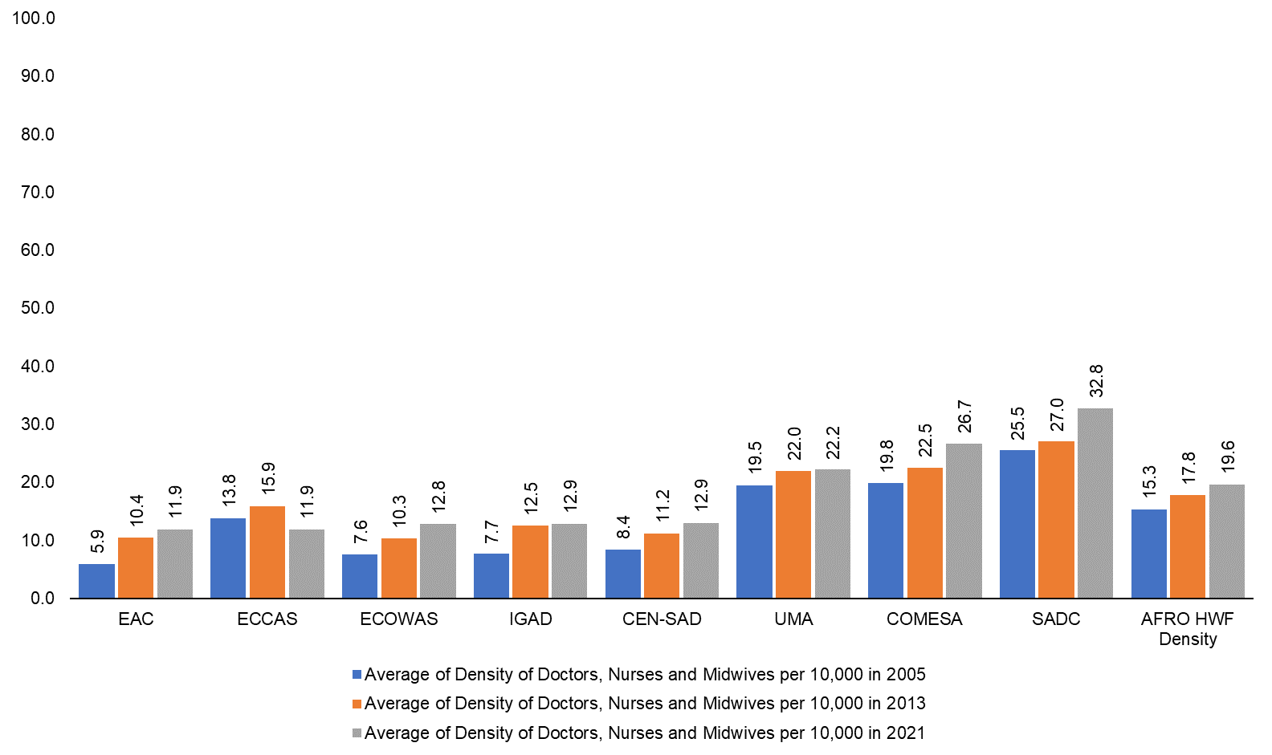
Figure 3: The trends of doctors, nurses and midwives density per 10,000 population between 2005 and 2021 with the trading blocks

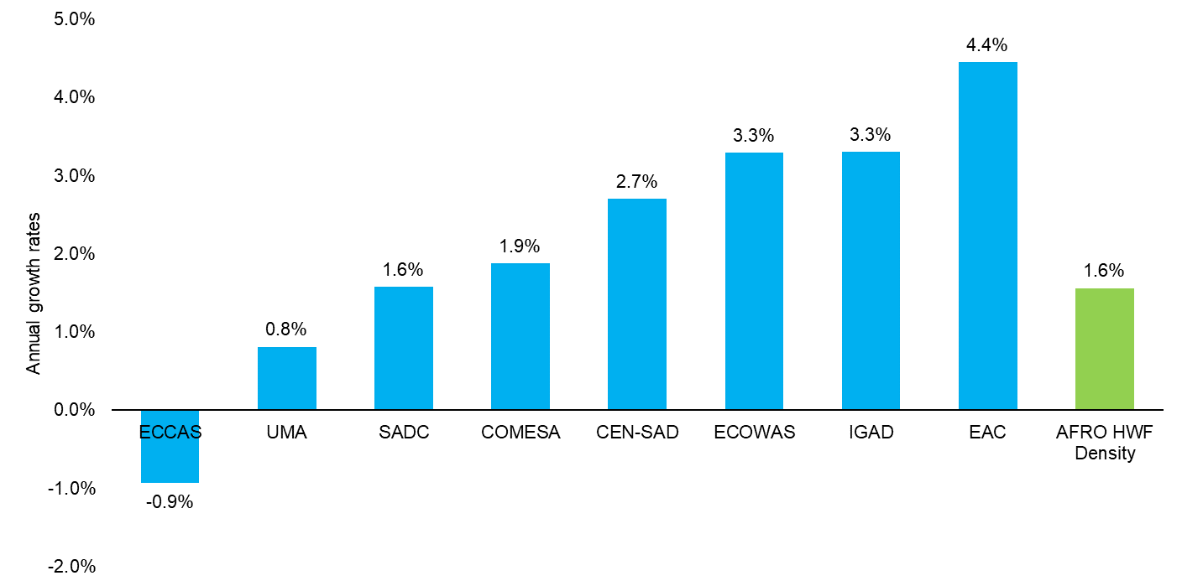
Figure 4: Compound annual growth of Health Workforce between 2005 and 2021 in the WHO AFRO region with the trading blocks

3.3 Trends in the stock and density of health workers with countries income levels

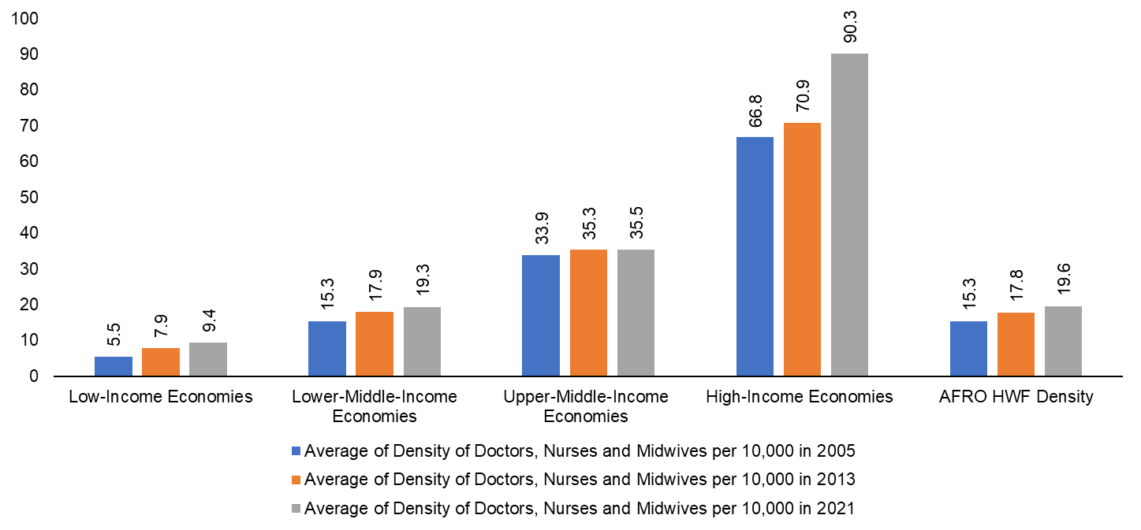
Figure 5: Densities of doctors, nurses and midwifes per 10,000 population with income groups

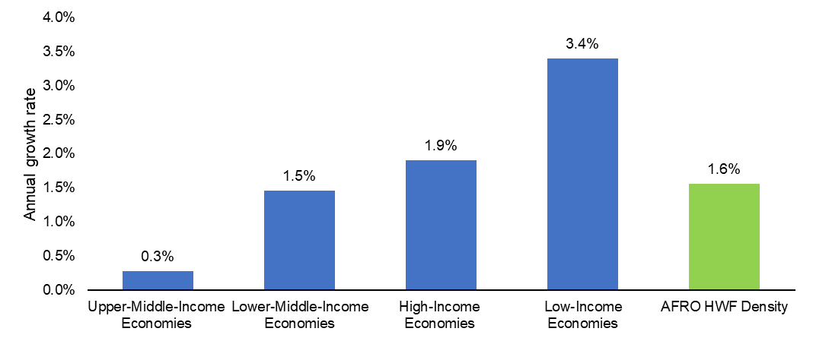
Figure 6: Compound annual growth of Health Workforce between 2005 and 2021 in the WHO AFRO region with income levels

- Health Education, Training and Accreditation

Update from the previous report – for countries, there is new data on the training capacity of 2022

4.1 Health training institutions

XXXXXXX

4.2. Accreditation of health training institutions

XXXXXX

- Health workforce labour flows

Overview of the Labour flows (inflows and out-flows), including migration – synthesis from HLMA reports – 13 countries.

- Health workforce (un)employment rates

Health workforce (un)employment (from 1st edition of State of HWF report and 13 HLMA reports – quantify annual employment of HWs and number of unemployed HWs by cadre)

- Supply, demand and the need for health care workers

Synthesis of projected supply, demand and need for health workers (to be integrated with other ongoing work).
Simulating the optimal mix of health workforce cadres

- Health workforce budget and spending

Integrate analysis on health workforce spending and budget space (use paper by Pascal et al 2023 + projection from AFRO model).

- Governance and management of health workforce

State of health workforce governance and stewardship/leadership (use dataset collected in NHWA v2 AFRO + from 1st edition of State of HWF report)

- Status of health workforce through the lenses of performance indicators

Assessment of key performance indicators compared to targets/thresholds (to be finalised after the main analysis).

- Synthesis of health workforce trends and their impacts

Explore reasons for the observed trends and the impact of HWF on health and socio-economic indicators.

- Conclusions
From each of the chapters above

- Recommendations
Recommended actions for the next of half of the SDG era, 2025 – 2030.

References

XXXXX

Appendices
XXXXX

